Mata Kuliah | : | Pemrograman Web Lanjut (PWL)
Program Studi | : | D4 – Teknik Informatika
Semester | : | 4
Kelas | : | TI 2A
NIM | : | 244107020240
Nama | : | Mochammad Rijal Dzaki Rifki Afifudin
Jobsheet Ke- | : | 6
GitHub | : | https://github.com/Zinc-zn/14_PWL

Laporan Jobsheet

- Implementasi Form Elements & Resource Post di Filament
Langkah | Jawaban/Deskripsi
1 | Membuat Resource Post  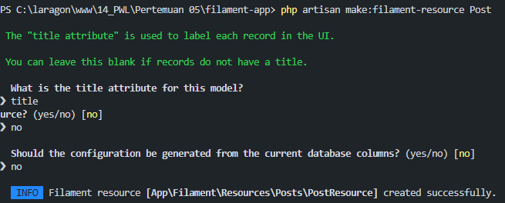  Setelah selesai, akan terbentuk folder:  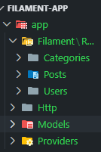  Refresh halaman /admin → menu Posts muncul.  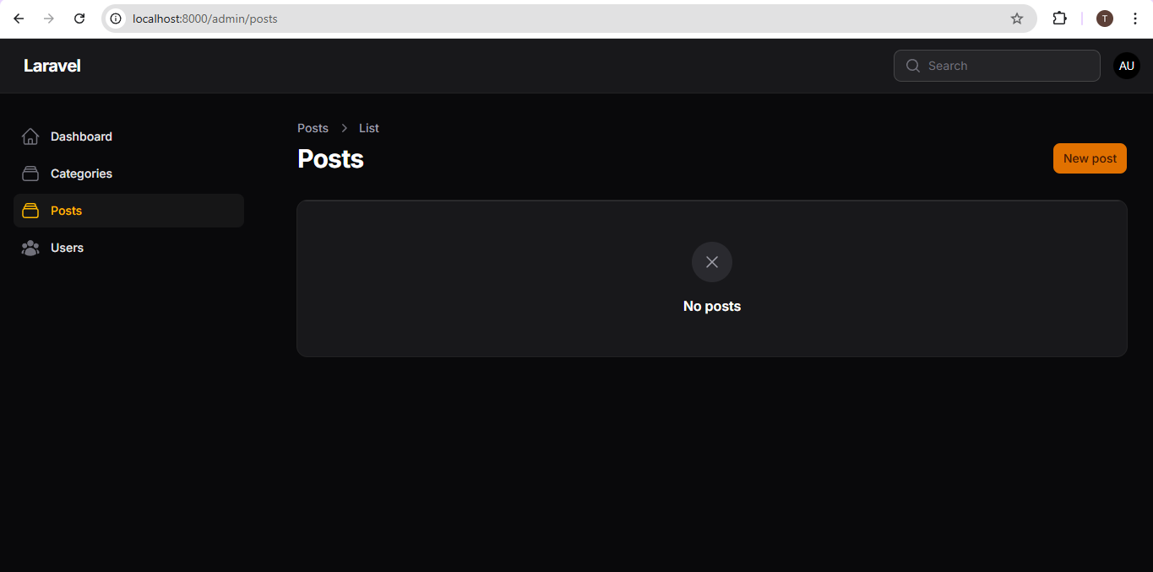
2 | Implementasi Form Elements  1. Text Input (Title & Slug)  Modifikasi kode PostForm.php  <?php  namespace App\Filament\Resources\Posts\Schemas;  use Filament\Schemas\Schema;  use Filament\Forms\Components\TextInput;  class PostForm  {  public static function configure(Schema $schema): Schema  {  return $schema  ->components([  //  TextInput::make("title"),  TextInput::make("slug"),  ]);  }  }  Jalankan browser :  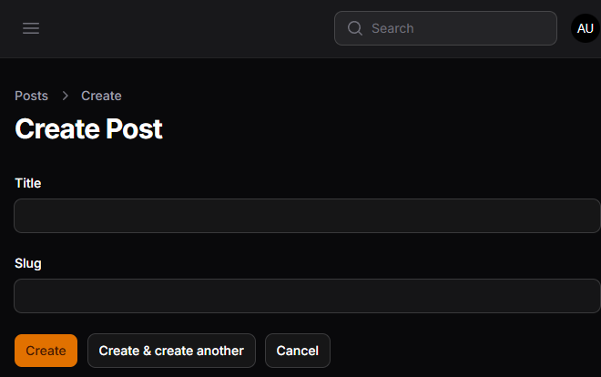  2. Select (Relasi Category)  Modifikasi kode PostForm.php  <?php  namespace App\Filament\Resources\Posts\Schemas;  use Filament\Schemas\Schema;  use Filament\Forms\Components\TextInput;  use Filament\Forms\Components\Select;  class PostForm  {  public static function configure(Schema $schema): Schema  {  return $schema  ->components([  //  TextInput::make("title"),  TextInput::make("slug"),  Select::make("category_id")  ->relationship("category", "name")  ->preload()  ->searchable(),  ]);  }  }  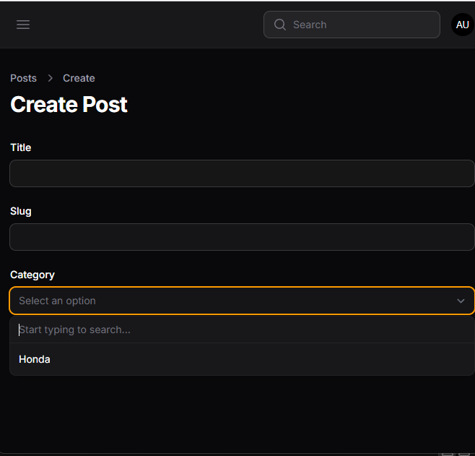  3. Color Picker  Modifikasi kode PostForm.php  <?php  namespace App\Filament\Resources\Posts\Schemas;  use Filament\Schemas\Schema;  use Filament\Forms\Components\TextInput;  use Filament\Forms\Components\Select;  use Filament\Forms\Components\ColorPicker;  class PostForm  {  public static function configure(Schema $schema): Schema  {  return $schema  ->components([  //  TextInput::make("title"),  TextInput::make("slug"),  Select::make("category_id")  ->relationship("category", "nama")  ->preload()  ->searchable(),  ColorPicker::make("color"),  ]);  }  }  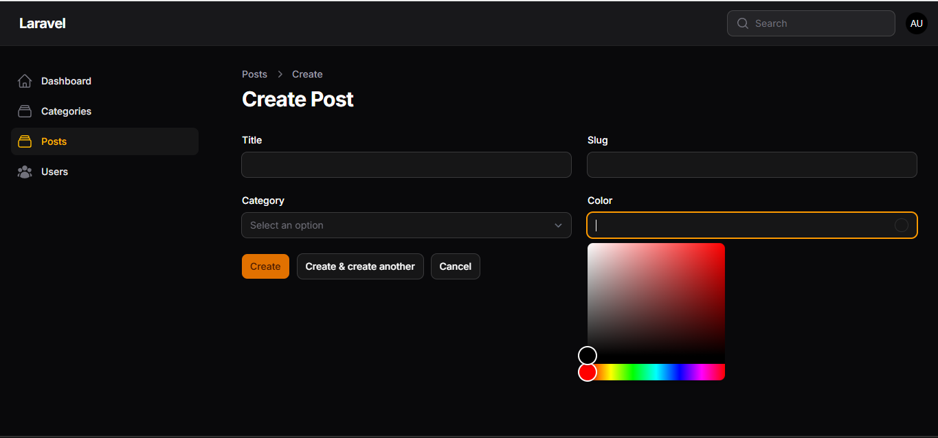  4. Markdown / Rich Editor (body)  Markdown:  Modifikasi kode PostForm.ph  <?php  namespace App\Filament\Resources\Posts\Schemas;  use Filament\Schemas\Schema;  use Filament\Forms\Components\TextInput;  use Filament\Forms\Components\Select;  use Filament\Forms\Components\ColorPicker;  use Filament\Forms\Components\MarkdownEditor;  class PostForm  {  public static function configure(Schema $schema): Schema  {  return $schema  ->components([  //  TextInput::make("title"),  TextInput::make("slug"),  Select::make("category_id")  ->relationship("category", "nama")  ->preload()  ->searchable(),  ColorPicker::make("color"),  MarkdownEditor::make("content"),  ]);  }  }  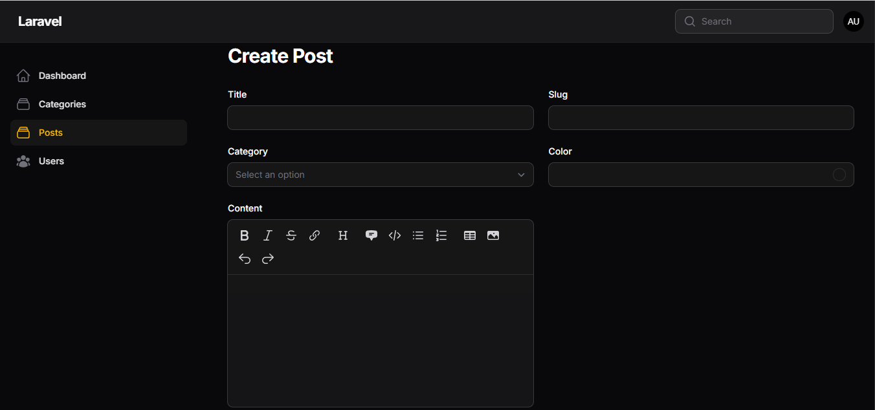  Rich Editor:  Modifikasi kode PostForm.php  <?php  namespace App\Filament\Resources\Posts\Schemas;  use Filament\Schemas\Schema;  use Filament\Forms\Components\TextInput;  use Filament\Forms\Components\Select;  use Filament\Forms\Components\ColorPicker;  use Filament\Forms\Components\MarkdownEditor;  use Filament\Forms\Components\RichEditor;  class PostForm  {  public static function configure(Schema $schema): Schema  {  return $schema  ->components([  //  TextInput::make("title"),  TextInput::make("slug"),  Select::make("category_id")  ->relationship("category", "nama")  ->preload()  ->searchable(),  ColorPicker::make("color"),  RichEditor::make("content"),  ]);  }  }  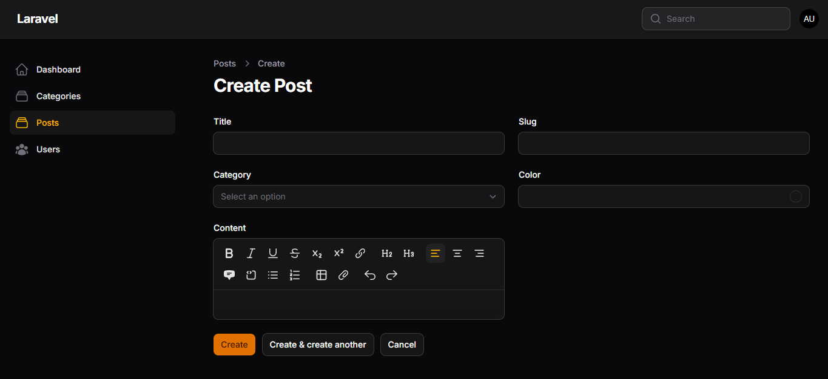  5. File Upload  Modifikasi kode PostForm.php  <?php  namespace App\Filament\Resources\Posts\Schemas;  use Filament\Schemas\Schema;  use Filament\Forms\Components\TextInput;  use Filament\Forms\Components\Select;  use Filament\Forms\Components\ColorPicker;  use Filament\Forms\Components\MarkdownEditor;  use Filament\Forms\Components\RichEditor;  use Filament\Forms\Components\FileUpload;  use Filament\Forms\Components\TagsEditor;  class PostForm  {  public static function configure(Schema $schema): Schema  {  return $schema  ->components([  //  TextInput::make("title"),  TextInput::make("slug"),  Select::make("category_id")  ->relationship("category", "nama")  ->preload()  ->searchable(),  ColorPicker::make("color"),  // RichEditor::make("content"),  FileUpload::make("Image")  ->disk("public")  ->directory("posts")  ]);  }  }  Hasil:  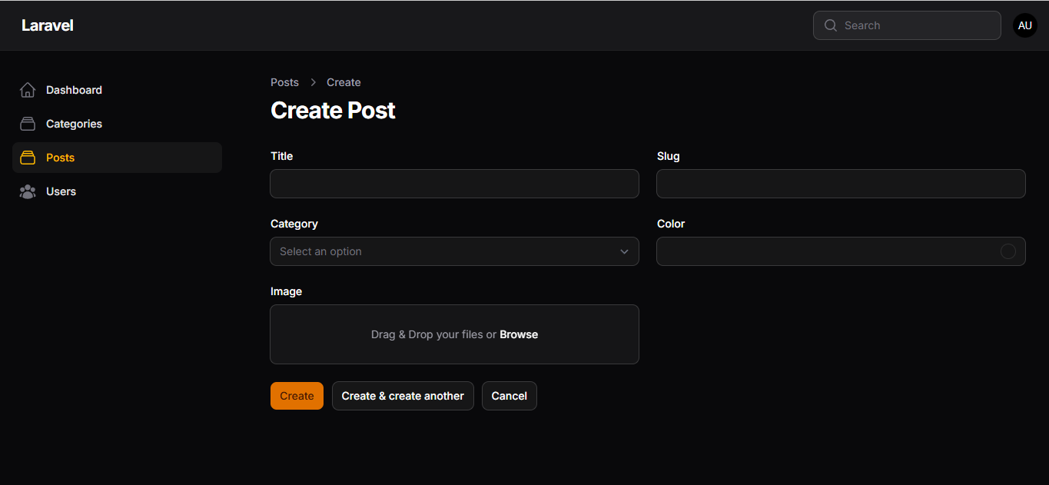  6. Tags Input  Modifikasi kode PostForm.php:  <?php  namespace App\Filament\Resources\Posts\Schemas;  use Filament\Schemas\Schema;  use Filament\Forms\Components\TextInput;  use Filament\Forms\Components\Select;  use Filament\Forms\Components\ColorPicker;  use Filament\Forms\Components\MarkdownEditor;  use Filament\Forms\Components\RichEditor;  use Filament\Forms\Components\FileUpload;  use Filament\Forms\Components\TagsInput;  class PostForm  {  public static function configure(Schema $schema): Schema  {  return $schema  ->components([  //  TextInput::make("title"),  TextInput::make("slug"),  Select::make("category_id")  ->relationship("category", "nama")  ->preload()  ->searchable(),  ColorPicker::make("color"),  RichEditor::make("content"),  FileUpload::make("Image")  ->disk("public")  ->directory("posts"),  TagsInput::make("tags"),  ]);  }  }  Hasil:  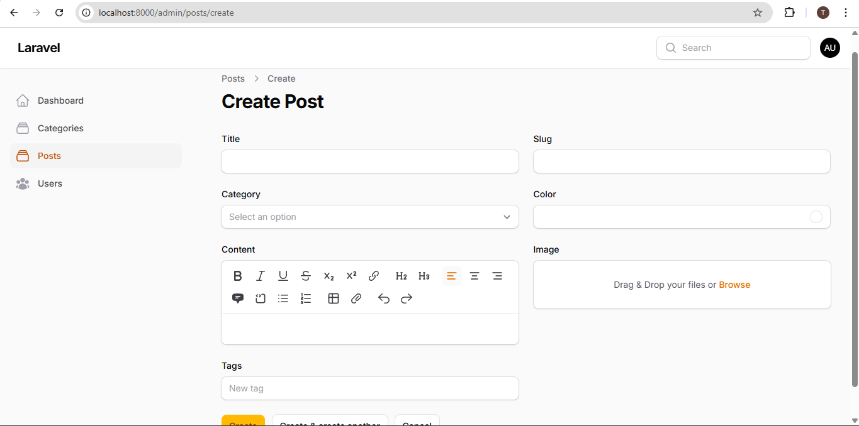  7. CheckBox (Published)  Modifikasi kode program:  <?php  namespace App\Filament\Resources\Posts\Schemas;  use Filament\Schemas\Schema;  use Filament\Forms\Components\TextInput;  use Filament\Forms\Components\Select;  use Filament\Forms\Components\ColorPicker;  use Filament\Forms\Components\MarkdownEditor;  use Filament\Forms\Components\RichEditor;  use Filament\Forms\Components\FileUpload;  use Filament\Forms\Components\TagsInput;  use Filament\Forms\Components\Checkbox;  class PostForm  {  public static function configure(Schema $schema): Schema  {  return $schema  ->components([  //  TextInput::make("title"),  TextInput::make("slug"),  Select::make("category_id")  ->relationship("category", "nama")  ->preload()  ->searchable(),  ColorPicker::make("color"),  RichEditor::make("content"),  FileUpload::make("Image")  ->disk("public")  ->directory("posts"),  TagsInput::make("tags"),  Checkbox::make("published"),  ]);  }  }  Hasil:  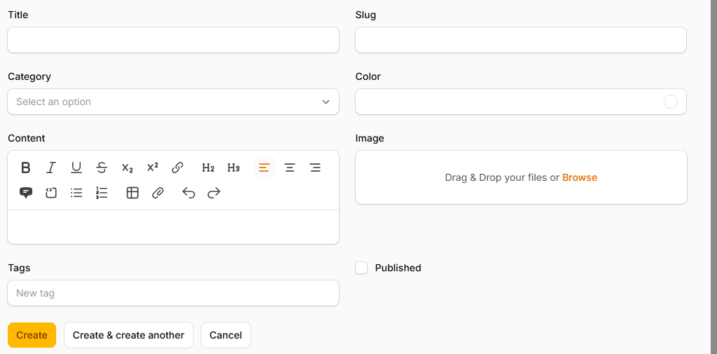  8. Date Picker (Publish At)  Modifikasi kode program:  <?php  namespace App\Filament\Resources\Posts\Schemas;  use Filament\Schemas\Schema;  use Filament\Forms\Components\TextInput;  use Filament\Forms\Components\Select;  use Filament\Forms\Components\ColorPicker;  use Filament\Forms\Components\MarkdownEditor;  use Filament\Forms\Components\RichEditor;  use Filament\Forms\Components\FileUpload;  use Filament\Forms\Components\TagsInput;  use Filament\Forms\Components\Checkbox;  use Filament\Forms\Components\DateTimePicker;  class PostForm  {  public static function configure(Schema $schema): Schema  {  return $schema  ->components([  //  TextInput::make("title"),  TextInput::make("slug"),  Select::make("category_id")  ->relationship("category", "nama")  ->preload()  ->searchable(),  ColorPicker::make("color"),  RichEditor::make("content"),  FileUpload::make("Image")  ->disk("public")  ->directory("posts"),  TagsInput::make("tags"),  Checkbox::make("published"),  dateTimePicker::make("published_at"),  ]);  }  }  Hasil:  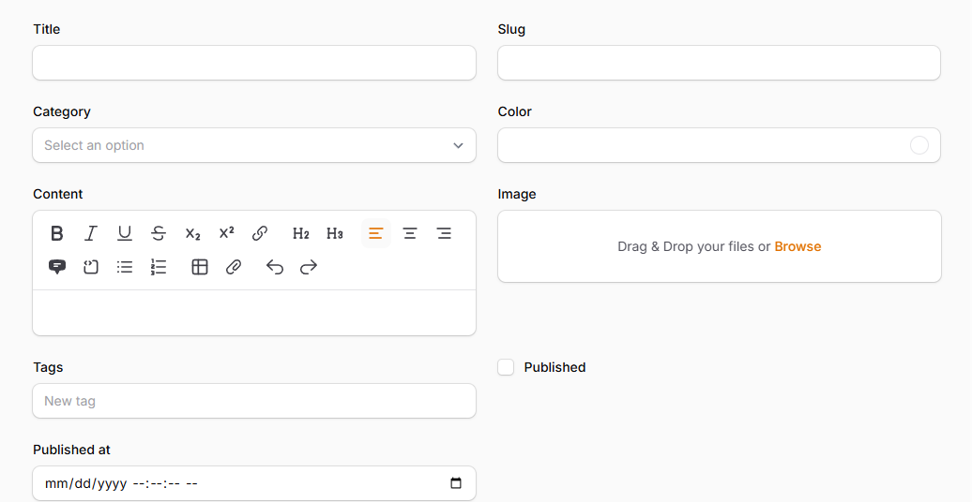
3 | Menampilkan Data di table  Inputan data pada post:  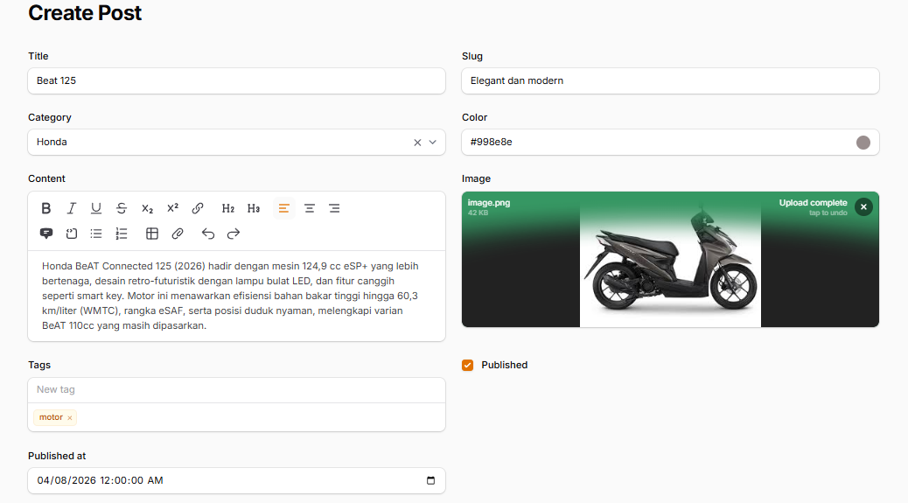  Modifikasi kode PostTable.php:  <?php  namespace App\Filament\Resources\Posts\Tables;  use Filament\Actions\BulkActionGroup;  use Filament\Actions\DeleteBulkAction;  use Filament\Actions\EditAction;  use Filament\Schemas\Components\Image;  use Filament\Tables\Table;  use Filament\Tables\Columns\TextColumn;  use Filament\Tables\Columns\ColorColumn;  use Filament\Tables\Columns\ImageColumn;  use Symfony\Component\Console\Color;  class PostsTable  {  public static function configure(Table $table): Table  {  return $table  ->columns([  //  TextColumn::make('title'),  TextColumn::make('slug'),  TextColumn::make('category.name'),  ColorColumn::make('color'),  ImageColumn::make('image')  ->disk('public'),  ])  ->filters([  //  ])  ->recordActions([  EditAction::make(),  ])  ->toolbarActions([  BulkActionGroup::make([  DeleteBulkAction::make(),  ]),  ]);  }  }  Jalankan perintah php artisan storage:link pada terminal untuk menampilkan gambar  Hasil:  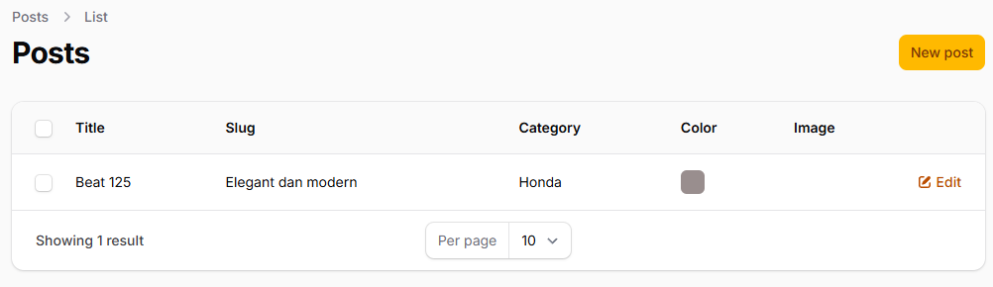
4 | Analisis diskusi:  1. Mengapa kita perlu storage:link?  Jawaban:  Fungsi storage:link: Perintah php artisan storage:link membuat sebuah symbolic link (jalan pintas) dari folder public/storage yang mengarah ke storage/app/public.  Hasilnya: Setelah di-link, file yang disimpan di dalam storage kini memiliki URL publik dan bisa ditampilkan di website Anda (misalnya: namawebsite.com/storage/gambar.png).  2. Apa fungsi $casts untuk field JSON?  Jawaban:  Otomatisasi: Dengan menambahkan protected $casts = ['nama_kolom' => 'array']; di model Eloquent, Laravel akan secara otomatis mengubah (meng-cast) string JSON tersebut menjadi Array PHP saat data diambil dari database.  Penyimpanan Mudah: Sebaliknya, saat Anda menyimpan Array PHP ke kolom tersebut, Laravel akan otomatis mengubahnya kembali menjadi string JSON sebelum dimasukkan ke database. Ini membuat proses baca-tulis data jauh lebih praktis.  3. Mengapa kita menggunakan category.name bukan category_id?  Jawaban:  category_id: Hanya akan menampilkan angka (misal: 1, 2, 3). Angka ini adalah Foreign Key dari database, yang tentu saja membingungkan dan tidak memiliki makna bagi pengguna biasa.  category.name: Menggunakan fitur relasi (Relationship) Eloquent Laravel. Sistem akan mencari kategori dengan ID tersebut di tabel categories, lalu mengambil kolom name-nya. Hasilnya yang tampil adalah teks yang bisa dibaca manusia (misal: "Elektronik", "Pakaian"), sehingga aplikasi menjadi jauh lebih user-friendly.  4. Apa perbedaan RichEditor dan MarkdownEditor?  Jawaban:  RichEditor (WYSIWYG):  Cara kerja: Singkatan dari What You See Is What You Get. Tampilannya mirip Microsoft Word. Anda memblok teks, lalu mengklik tombol (B) untuk menebalkan teks.  Output: Menghasilkan kode HTML murni (contoh: <b>Teks Tebal</b>).  Pengguna: Sangat cocok untuk pengguna awam (non-teknis) karena sangat mudah digunakan secara visual.  MarkdownEditor:  Cara kerja: Berbasis sintaks teks. Anda harus mengetikkan simbol tertentu untuk memformat teks. Misalnya, Anda mengetik **Teks Tebal** secara manual.  Output: Menghasilkan teks Markdown murni. Jika ingin menampilkannya di website, Anda butuh parser untuk mengubah Markdown tersebut menjadi HTML.  Pengguna: Biasanya disukai oleh developer, penulis teknis, atau orang yang terbiasa mengetik cepat tanpa ingin melepaskan tangan dari keyboard untuk mengklik tombol. Hasil datanya juga lebih bersih dibandingkan HTML bawaan RichEditor.
5

- Custom Layout Form dengan Section & Group di Filament
Langkah | Jawaban/Deskripsi
1 | Mengatur Layout Dasar dengan Columns  Modifikasi kode PostForm.php:  <?php  namespace App\Filament\Resources\Posts\Schemas;  use Filament\Schemas\Schema;  use Filament\Forms\Components\TextInput;  use Filament\Forms\Components\Select;  use Filament\Forms\Components\ColorPicker;  use Filament\Forms\Components\MarkdownEditor;  use Filament\Forms\Components\RichEditor;  use Filament\Forms\Components\FileUpload;  use Filament\Forms\Components\TagsInput;  use Filament\Forms\Components\Checkbox;  use Filament\Forms\Components\DateTimePicker;  class PostForm  {  public static function configure(Schema $schema): Schema  {  return $schema  ->components([  //  TextInput::make("title"),  TextInput::make("slug"),  Select::make("category_id")  ->relationship("category", "nama")  ->preload()  ->searchable(),  ColorPicker::make("color"),  RichEditor::make("content"),  FileUpload::make("image")  ->disk("public")  ->directory("posts"),  TagsInput::make("tags"),  Checkbox::make("published"),  dateTimePicker::make("published_at"),  ])->columns(3);  }  }  Hasil:  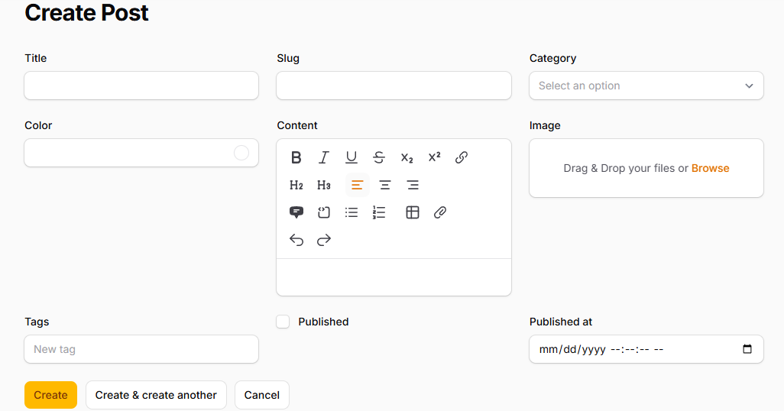  Modifikasi Kode PostForm.php:  <?php  namespace App\Filament\Resources\Posts\Schemas;  use Filament\Schemas\Schema;  use Filament\Forms\Components\TextInput;  use Filament\Forms\Components\Select;  use Filament\Forms\Components\ColorPicker;  use Filament\Forms\Components\MarkdownEditor;  use Filament\Forms\Components\RichEditor;  use Filament\Forms\Components\FileUpload;  use Filament\Forms\Components\TagsInput;  use Filament\Forms\Components\Checkbox;  use Filament\Forms\Components\DateTimePicker;  use Filament\Schemas\Components\Section;  class PostForm  {  public static function configure(Schema $schema): Schema  {  return $schema  ->components([  //  Section::make("Post Details")  ->schema([  TextInput::make("title"),  TextInput::make("slug"),  Select::make("category_id")  ->relationship("category", "nama")  ->preload()  ->searchable(),  ColorPicker::make("color"),  MarkdownEditor::make("content"),  ]),  // RichEditor::make("content"),  FileUpload::make("image")  ->disk("public")  ->directory("posts"),  TagsInput::make("tags"),  Checkbox::make("published"),  dateTimePicker::make("published_at"),  ])->columns(2);  }  }  Hasil:  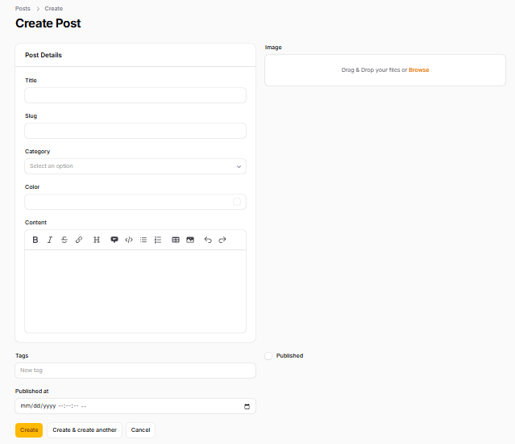
2 | Menggunakan Section  1. Membuat Section "Post Details":  Modifikasi kode PostForm.php:  <?php  namespace App\Filament\Resources\Posts\Schemas;  use Filament\Schemas\Schema;  use Filament\Forms\Components\TextInput;  use Filament\Forms\Components\Select;  use Filament\Forms\Components\ColorPicker;  use Filament\Forms\Components\MarkdownEditor;  use Filament\Forms\Components\RichEditor;  use Filament\Forms\Components\FileUpload;  use Filament\Forms\Components\TagsInput;  use Filament\Forms\Components\Checkbox;  use Filament\Forms\Components\DateTimePicker;  use Filament\Schemas\Components\Section;  use Filament\Support\Icons\Heroicon;  class PostForm  {  public static function configure(Schema $schema): Schema  {  return $schema  ->components([  // section 1 - post details  Section::make("Post Details")  -> description("Fill in the details of the post")  // icon(Heroicon::RocketLaunch)  -> icon('Heroicon-o-document-text')  ->schema([  TextInput::make("title"),  TextInput::make("slug"),  Select::make("category_id")  ->relationship("category", "nama")  ->preload()  ->searchable(),  ColorPicker::make("color"),  MarkdownEditor::make("content"),  ]),  // RichEditor::make("content"),  FileUpload::make("image")  ->disk("public")  ->directory("posts"),  TagsInput::make("tags"),  Checkbox::make("published"),  dateTimePicker::make("published_at"),  ])->columns(2);  }  }  Hasil:  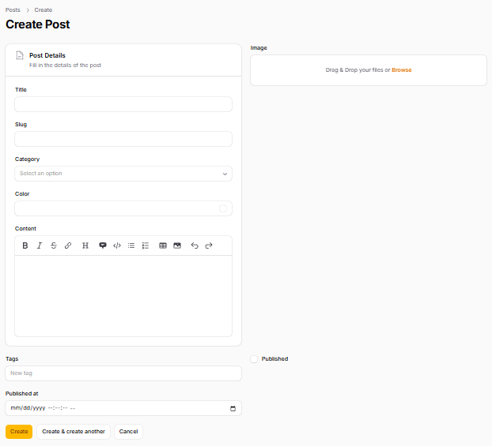
3 | Membuat Section Terpisah  1. Section Image Upload:  Modifikasi kode PostForm.php:  <?php  namespace App\Filament\Resources\Posts\Schemas;  use Filament\Schemas\Schema;  use Filament\Forms\Components\TextInput;  use Filament\Forms\Components\Select;  use Filament\Forms\Components\ColorPicker;  use Filament\Forms\Components\MarkdownEditor;  use Filament\Forms\Components\RichEditor;  use Filament\Forms\Components\FileUpload;  use Filament\Forms\Components\TagsInput;  use Filament\Forms\Components\Checkbox;  use Filament\Forms\Components\DateTimePicker;  use Filament\Schemas\Components\Section;  use Filament\Support\Icons\Heroicon;  class PostForm  {  public static function configure(Schema $schema): Schema  {  return $schema  ->components([  // section 1 - post details  Section::make("Post Details")  -> description("Fill in the details of the post")  // icon(Heroicon::RocketLaunch)  -> icon('heroicon-o-document-text')  ->schema([  TextInput::make("title"),  TextInput::make("slug"),  Select::make("category_id")  ->relationship("category", "nama")  ->preload()  ->searchable(),  ColorPicker::make("color"),  MarkdownEditor::make("content"),  ]),  // section 2 - image  Section::make("Image Upload")  ->schema([  FileUpload::make("image")  ->disk("public")  ->directory("posts"),  ]),  // RichEditor::make("content"),  TagsInput::make("tags"),  Checkbox::make("published"),  dateTimePicker::make("published_at"),  ])->columns(2);  }  }  Hasil:  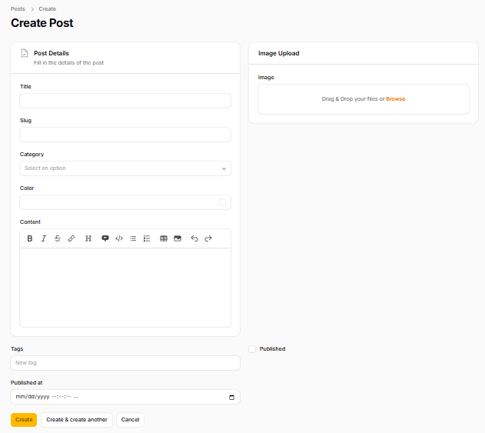  2. Section Meta Data  Modifikasi kode PostForm.php:  <?php  namespace App\Filament\Resources\Posts\Schemas;  use Filament\Schemas\Schema;  use Filament\Forms\Components\TextInput;  use Filament\Forms\Components\Select;  use Filament\Forms\Components\ColorPicker;  use Filament\Forms\Components\MarkdownEditor;  use Filament\Forms\Components\RichEditor;  use Filament\Forms\Components\FileUpload;  use Filament\Forms\Components\TagsInput;  use Filament\Forms\Components\Checkbox;  use Filament\Forms\Components\DateTimePicker;  use Filament\Schemas\Components\Section;  use Filament\Support\Icons\Heroicon;  class PostForm  {  public static function configure(Schema $schema): Schema  {  return $schema  ->components([  // section 1 - post details  Section::make("Post Details")  -> description("Fill in the details of the post")  // icon(Heroicon::RocketLaunch)  -> icon('heroicon-o-document-text')  ->schema([  TextInput::make("title"),  TextInput::make("slug"),  Select::make("category_id")  ->relationship("category", "nama")  ->preload()  ->searchable(),  ColorPicker::make("color"),  MarkdownEditor::make("content"),  ]),  // section 2 - image  Section::make("Image Upload")  ->schema([  FileUpload::make("image")  ->disk("public")  ->directory("posts"),  ]),  // RichEditor::make("content"),  //section 3 - meta  section::make("Meta Infromation")  ->schema([  TagsInput::make("tags"),  Checkbox::make("published"),  dateTimePicker::make("published_at"),  ])  ])->columns(2);  }  }  Hasil:  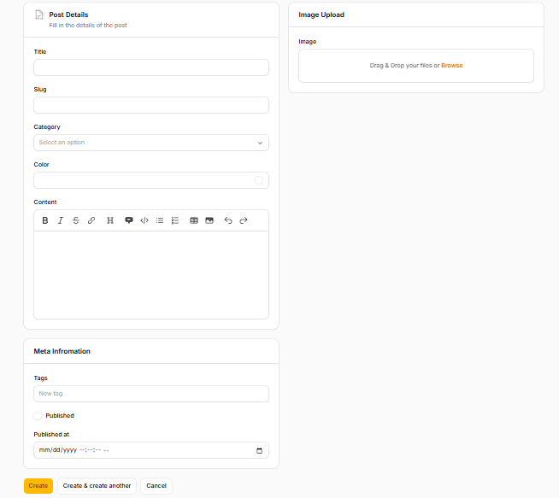  Jika ingin tampilan full size, maka modifikasi baris kode  section::make("Meta Infromation")  ->schema([  TagsInput::make("tags"),  Checkbox::make("published"),  dateTimePicker::make("published_at"),  ])->columnSpanFull(),  Hasil:  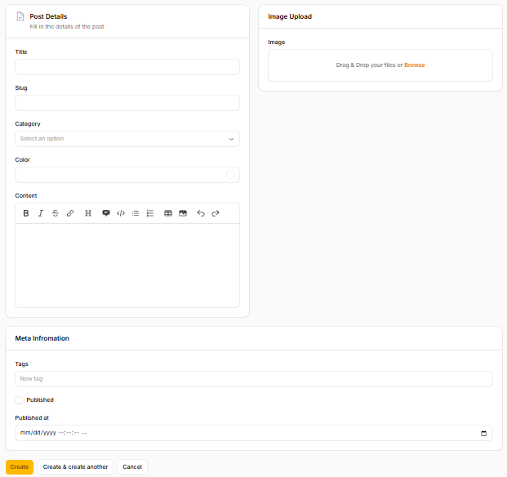
4 | Menggunakan Group untuk Layout Horizontal  Modifikasi kode PostForm.php  <?php  namespace App\Filament\Resources\Posts\Schemas;  use DateTime;  use Filament\Schemas\Schema;  use Filament\Forms\Components\TextInput;  use Filament\Forms\Components\Select;  use Filament\Forms\Components\ColorPicker;  use Filament\Forms\Components\MarkdownEditor;  use Filament\Forms\Components\RichEditor;  use Filament\Forms\Components\FileUpload;  use Filament\Forms\Components\TagsInput;  use Filament\Forms\Components\Checkbox;  use Filament\Forms\Components\DateTimePicker;  use Filament\Schemas\Components\Section;  use Filament\Support\Icons\Heroicon;  use Filament\Schemas\Components\Group;  class PostForm  {  public static function configure(Schema $schema): Schema  {  return $schema  ->components([  // Section 1 - Post Details  Section::make("Post Details")  ->description("Fill in the details of the post")  ->icon('heroicon-o-document-text')  ->schema([  TextInput::make("title"),  TextInput::make("slug"),  Select::make("category_id")  ->relationship("category", "nama")  ->preload()  ->searchable(),  ColorPicker::make("color"),  MarkdownEditor::make("content"),  ]),  // Grouping fields into 2 columns  Group::make([  // Section 2 - Image  Section::make("Image Upload")  ->schema([  FileUpload::make("image")  ->disk("public")  ->directory("posts"),  ]),  // Section 3 - Meta  Section::make("Meta Information")  ->schema([  TagsInput::make("tags"),  Checkbox::make("published"),  ])->columns(2),  DateTimePicker::make("published_at"),  ]),  ])->columns(2);  }  }  Hasil:  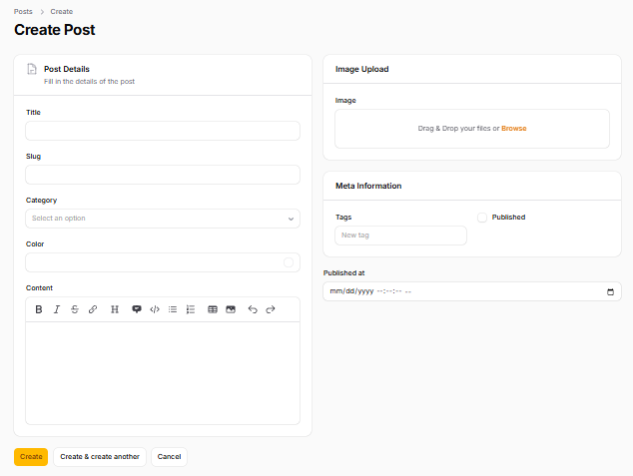  Modifikasi kode PostForm.php  <?php  namespace App\Filament\Resources\Posts\Schemas;  use DateTime;  use Filament\Schemas\Schema;  use Filament\Forms\Components\TextInput;  use Filament\Forms\Components\Select;  use Filament\Forms\Components\ColorPicker;  use Filament\Forms\Components\MarkdownEditor;  use Filament\Forms\Components\RichEditor;  use Filament\Forms\Components\FileUpload;  use Filament\Forms\Components\TagsInput;  use Filament\Forms\Components\Checkbox;  use Filament\Forms\Components\DateTimePicker;  use Filament\Schemas\Components\Section;  use Filament\Support\Icons\Heroicon;  use Filament\Schemas\Components\Group;  class PostForm  {  public static function configure(Schema $schema): Schema  {  return $schema  ->components([  // Section 1 - Post Details  Section::make("Post Details")  ->description("Fill in the details of the post")  ->icon('heroicon-o-document-text')  ->schema([  TextInput::make("title"),  TextInput::make("slug"),  Select::make("category_id")  ->relationship("category", "nama")  ->preload()  ->searchable(),  ColorPicker::make("color"),  MarkdownEditor::make("content"),  ])->columnSpan(2),  // Grouping fields into 2 columns  Group::make([  // Section 2 - Image  Section::make("Image Upload")  ->schema([  FileUpload::make("image")  ->disk("public")  ->directory("posts"),  ]),  // Section 3 - Meta  Section::make("Meta Information")  ->schema([  TagsInput::make("tags"),  Checkbox::make("published"),  ]),  DateTimePicker::make("published_at"),  ])->columnSpan(1)  ])->columns(3);  }  }  Hasil:  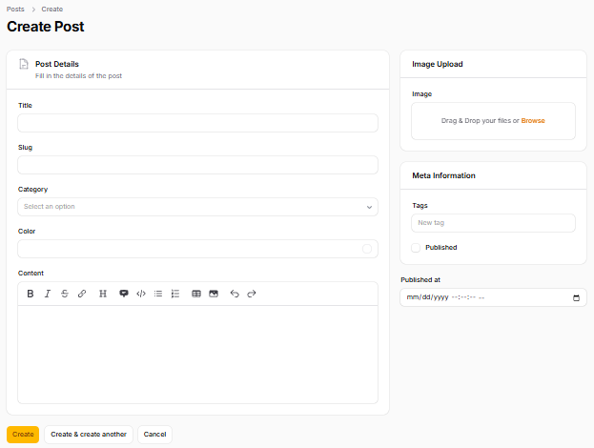
5 | Mengatur Lebar Field Individual  Modifikasi kode PostForm.php:  <?php  namespace App\Filament\Resources\Posts\Schemas;  use DateTime;  use Filament\Schemas\Schema;  use Filament\Forms\Components\TextInput;  use Filament\Forms\Components\Select;  use Filament\Forms\Components\ColorPicker;  use Filament\Forms\Components\MarkdownEditor;  use Filament\Forms\Components\RichEditor;  use Filament\Forms\Components\FileUpload;  use Filament\Forms\Components\TagsInput;  use Filament\Forms\Components\Checkbox;  use Filament\Forms\Components\DateTimePicker;  use Filament\Schemas\Components\Section;  use Filament\Support\Icons\Heroicon;  use Filament\Schemas\Components\Group;  class PostForm  {  public static function configure(Schema $schema): Schema  {  return $schema  ->components([  // Section 1 - Post Details  Section::make("Post Details")  ->description("Fill in the details of the post")  ->icon('heroicon-o-document-text')  ->schema([  Group::make([  TextInput::make("title"),  TextInput::make("slug"),  Select::make("category_id")  ->relationship("category", "nama")  ->preload()  ->searchable(),  ColorPicker::make("color"),  ])->columnSpan(2),  MarkdownEditor::make("content"),  ])->columnSpan(2),  // Grouping fields into 2 columns  Group::make([  // Section 2 - Image  Section::make("Image Upload")  ->schema([  FileUpload::make("image")  ->disk("public")  ->directory("posts"),  ]),  // Section 3 - Meta  Section::make("Meta Information")  ->schema([  TagsInput::make("tags"),  Checkbox::make("published"),  ]),  DateTimePicker::make("published_at"),  ])->columnSpan(1)  ])->columns(3);  }  }  Hasil:  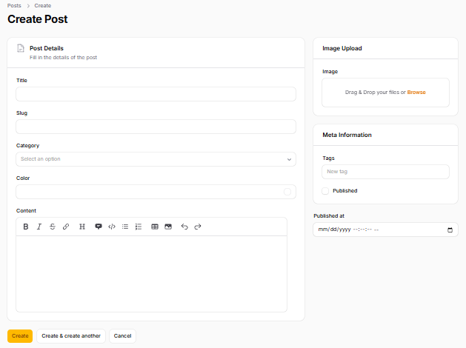
6 | Analisis Diskusi  1. Mengapa layout form penting dalam aplikasi admin?  Jawaban:  - Efisiensi Kerja: Tata letak yang logis memudahkan mata pengguna untuk memindai (scanning) formulir dengan cepat, sehingga mempercepat proses data entry.  - Mengurangi Cognitive Load (Beban Pikiran): Formulir panjang yang menumpuk dari atas ke bawah sangat melelahkan untuk dilihat. Dengan memecahnya ke dalam kolom atau blok visual, form terlihat lebih ringan dan rapi.  - Meminimalisir Kesalahan (Human Error): Mengelompokkan field yang saling berkaitan (misal: memisahkan blok "Data Utama" dan blok "Meta Data") membantu pengguna fokus dan mengurangi risiko salah isi.  2. Apa perbedaan Section dan Group?  Jawaban:  Section (Kelompok Visual):  - Memiliki wujud fisik di layar.  - Menciptakan sebuah "kartu" atau kotak putih dengan garis tepi (border).  - Bisa diberi judul (heading), deskripsi, ikon, dan bisa dibuat agar bisa diciutkan/dibuka (collapsible).  - Kapan dipakai? Saat Anda ingin memisahkan kategori data secara visual agar pengguna tahu bahwa kotak tersebut berisi kumpulan data spesifik (misal: Kotak "Informasi SEO").  Group (Kelompok Struktural/Transparan):  - Tidak terlihat oleh pengguna di layar (tidak ada kotak atau batas).  - Fungsinya murni di belakang layar untuk mengelompokkan komponen agar mematuhi aturan tata letak yang sama.  - Kapan dipakai? Saat Anda ingin menyatukan beberapa field ke dalam satu kolom grid tertentu, tanpa harus membungkusnya dengan kotak visual yang mungkin membuat tampilan UI terlalu ramai.  3. Kapan kita menggunakan columnSpanFull()?  Jawaban:  - Untuk field yang membutuhkan area pengetikan luas, seperti RichEditor, MarkdownEditor, atau Textarea.  - Untuk field yang menampilkan data memanjang, seperti tabel atau daftar checkbox yang banyak.  - Jika tidak di-set columnSpanFull(), editor teks (misalnya untuk konten artikel) akan terlihat sempit dan terhimpit di dalam satu kolom kecil, sehingga sangat tidak nyaman digunakan untuk mengetik panjang.  4. Apa keuntungan sistem grid 12 kolom?  Jawaban:  Fleksibilitas Pembagian Tinggi: Angka 12 adalah angka terkecil yang bisa dibagi rata dengan sangat banyak angka dasar, yaitu 1, 2, 3, 4, dan 6.  - Bagi 2 = columns(2) akan membagi layar 50% | 50% (masing-masing 6 kolom).  - Bagi 3 = columns(3) akan membagi layar 33% | 33% | 33% (masing-masing 4 kolom).  - Bagi 4 = columns(4) akan membagi layar 25% | 25% | 25% | 25% (masing-masing 3 kolom).  Tata Letak Asimetris: Anda bisa membuat desain kolom yang besar sebelah dengan mudah, misalnya kolom kiri memakan 8 bagian (66%) dan kolom kanan memakan 4 bagian (33%) untuk sidebar. Kombinasinya nyaris tidak terbatas untuk membuat UI yang proporsional.

- Implementasi Form Validation pada Filament
Langkah | Jawaban/Deskripsi
1 | Mengatur Layout Dasar dengan Columns  Cara Menambahkan Validasi  1. Menggunakan Method required()  Modifikasi kode PostForm.php:  <?php  namespace App\Filament\Resources\Posts\Schemas;  use DateTime;  use Filament\Schemas\Schema;  use Filament\Forms\Components\TextInput;  use Filament\Forms\Components\Select;  use Filament\Forms\Components\ColorPicker;  use Filament\Forms\Components\MarkdownEditor;  use Filament\Forms\Components\RichEditor;  use Filament\Forms\Components\FileUpload;  use Filament\Forms\Components\TagsInput;  use Filament\Forms\Components\Checkbox;  use Filament\Forms\Components\DateTimePicker;  use Filament\Schemas\Components\Section;  use Filament\Support\Icons\Heroicon;  use Filament\Schemas\Components\Group;  class PostForm  {  public static function configure(Schema $schema): Schema  {  return $schema  ->components([  // Section 1 - Post Details  Section::make("Post Details")  ->description("Fill in the details of the post")  ->icon('heroicon-o-document-text')  ->schema([  Group::make([  TextInput::make("title")  ->required()  ->maxLength(255),  TextInput::make("slug"),  Select::make("category_id")  ->relationship("category", "nama")  ->preload()  ->searchable(),  ColorPicker::make("color"),  ])->columnSpan(2),  MarkdownEditor::make("content"),  ])->columnSpan(2),  // Grouping fields into 2 columns  Group::make([  // Section 2 - Image  Section::make("Image Upload")  ->schema([  FileUpload::make("image")  ->disk("public")  ->directory("posts"),  ]),  // Section 3 - Meta  Section::make("Meta Information")  ->schema([  TagsInput::make("tags"),  Checkbox::make("published"),  ]),  DateTimePicker::make("published_at"),  ])->columnSpan(1)  ])->columns(3);  }  }  Hasil:  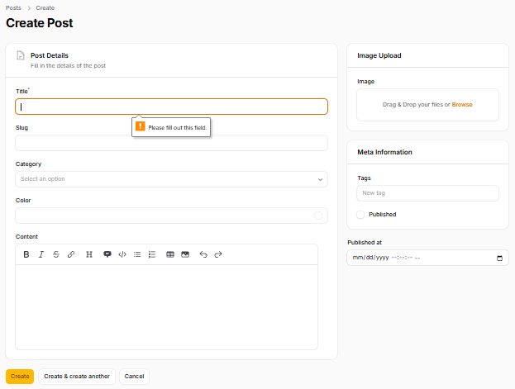  2. Menggunakan rule()  Modifikasi Kode PostForm.php  <?php  namespace App\Filament\Resources\Posts\Schemas;  use DateTime;  use Filament\Schemas\Schema;  use Filament\Forms\Components\TextInput;  use Filament\Forms\Components\Select;  use Filament\Forms\Components\ColorPicker;  use Filament\Forms\Components\MarkdownEditor;  use Filament\Forms\Components\RichEditor;  use Filament\Forms\Components\FileUpload;  use Filament\Forms\Components\TagsInput;  use Filament\Forms\Components\Checkbox;  use Filament\Forms\Components\DateTimePicker;  use Filament\Schemas\Components\Section;  use Filament\Support\Icons\Heroicon;  use Filament\Schemas\Components\Group;  class PostForm  {  public static function configure(Schema $schema): Schema  {  return $schema  ->components([  // Section 1 - Post Details  Section::make("Post Details")  ->description("Fill in the details of the post")  ->icon('heroicon-o-document-text')  ->schema([  Group::make([  TextInput::make("title")  ->rules('required'),  TextInput::make("slug"),  Select::make("category_id")  ->relationship("category", "nama")  ->preload()  ->searchable(),  ColorPicker::make("color"),  ])->columnSpan(2),  MarkdownEditor::make("content"),  ])->columnSpan(2),  // Grouping fields into 2 columns  Group::make([  // Section 2 - Image  Section::make("Image Upload")  ->schema([  FileUpload::make("image")  ->disk("public")  ->directory("posts"),  ]),  // Section 3 - Meta  Section::make("Meta Information")  ->schema([  TagsInput::make("tags"),  Checkbox::make("published"),  ]),  DateTimePicker::make("published_at"),  ])->columnSpan(1)  ])->columns(3);  }  }  Hasil:  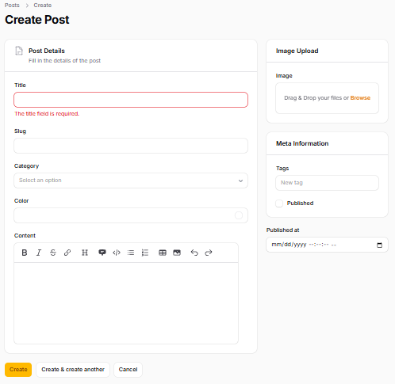  3. Menggunakan rules() (Multiple Validation)  Modifikasi kode PostForm.php  <?php  namespace App\Filament\Resources\Posts\Schemas;  use DateTime;  use Filament\Schemas\Schema;  use Filament\Forms\Components\TextInput;  use Filament\Forms\Components\Select;  use Filament\Forms\Components\ColorPicker;  use Filament\Forms\Components\MarkdownEditor;  use Filament\Forms\Components\RichEditor;  use Filament\Forms\Components\FileUpload;  use Filament\Forms\Components\TagsInput;  use Filament\Forms\Components\Checkbox;  use Filament\Forms\Components\DateTimePicker;  use Filament\Schemas\Components\Section;  use Filament\Support\Icons\Heroicon;  use Filament\Schemas\Components\Group;  class PostForm  {  public static function configure(Schema $schema): Schema  {  return $schema  ->components([  // Section 1 - Post Details  Section::make("Post Details")  ->description("Fill in the details of the post")  ->icon('heroicon-o-document-text')  ->schema([  Group::make([  TextInput::make("title")  ->rules('required | min:3 | max:10'),  TextInput::make("slug"),  Select::make("category_id")  ->relationship("category", "nama")  ->preload()  ->searchable(),  ColorPicker::make("color"),  ])->columnSpan(2),  MarkdownEditor::make("content"),  ])->columnSpan(2),  // Grouping fields into 2 columns  Group::make([  // Section 2 - Image  Section::make("Image Upload")  ->schema([  FileUpload::make("image")  ->disk("public")  ->directory("posts"),  ]),  // Section 3 - Meta  Section::make("Meta Information")  ->schema([  TagsInput::make("tags"),  Checkbox::make("published"),  ]),  DateTimePicker::make("published_at"),  ])->columnSpan(1)  ])->columns(3);  }  }  Hasil:  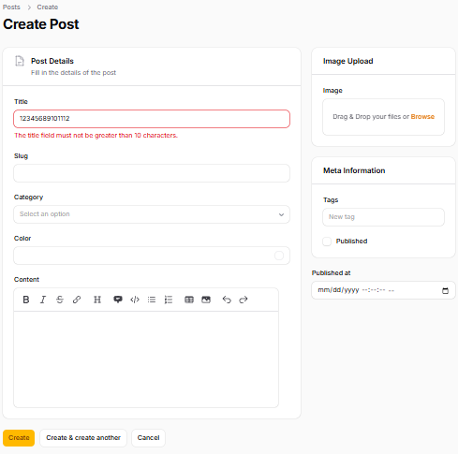
2 | Validasi Unique  Modifikasi kode PostForm.php  <?php  namespace App\Filament\Resources\Posts\Schemas;  use DateTime;  use Filament\Schemas\Schema;  use Filament\Forms\Components\TextInput;  use Filament\Forms\Components\Select;  use Filament\Forms\Components\ColorPicker;  use Filament\Forms\Components\MarkdownEditor;  use Filament\Forms\Components\RichEditor;  use Filament\Forms\Components\FileUpload;  use Filament\Forms\Components\TagsInput;  use Filament\Forms\Components\Checkbox;  use Filament\Forms\Components\DateTimePicker;  use Filament\Schemas\Components\Section;  use Filament\Support\Icons\Heroicon;  use Filament\Schemas\Components\Group;  class PostForm  {  public static function configure(Schema $schema): Schema  {  return $schema  ->components([  // Section 1 - Post Details  Section::make("Post Details")  ->description("Fill in the details of the post")  ->icon('heroicon-o-document-text')  ->schema([  Group::make([  TextInput::make("title")  ->rules('required | min:3 | max:10'),  TextInput::make("slug")  ->rule('required')  ->unique(),  Select::make("category_id")  ->relationship("category", "nama")  ->preload()  ->searchable(),  ColorPicker::make("color"),  ])->columnSpan(2),  MarkdownEditor::make("content"),  ])->columnSpan(2),  // Grouping fields into 2 columns  Group::make([  // Section 2 - Image  Section::make("Image Upload")  ->schema([  FileUpload::make("image")  ->disk("public")  ->directory("posts"),  ]),  // Section 3 - Meta  Section::make("Meta Information")  ->schema([  TagsInput::make("tags"),  Checkbox::make("published"),  ]),  DateTimePicker::make("published_at"),  ])->columnSpan(1)  ])->columns(3);  }  }  Hasil:  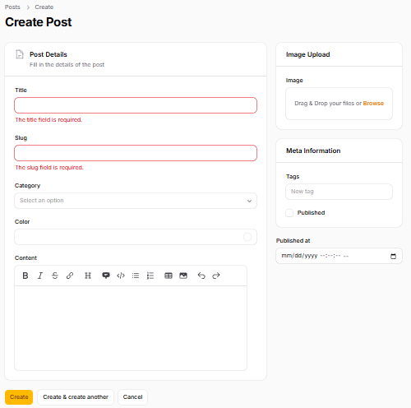
3 | Mengganti Pesan Error (Custom Message)  Modifikasi kode PostForm.php  <?php  namespace App\Filament\Resources\Posts\Schemas;  use DateTime;  use Filament\Schemas\Schema;  use Filament\Forms\Components\TextInput;  use Filament\Forms\Components\Select;  use Filament\Forms\Components\ColorPicker;  use Filament\Forms\Components\MarkdownEditor;  use Filament\Forms\Components\RichEditor;  use Filament\Forms\Components\FileUpload;  use Filament\Forms\Components\TagsInput;  use Filament\Forms\Components\Checkbox;  use Filament\Forms\Components\DateTimePicker;  use Filament\Schemas\Components\Section;  use Filament\Support\Icons\Heroicon;  use Filament\Schemas\Components\Group;  class PostForm  {  public static function configure(Schema $schema): Schema  {  return $schema  ->components([  // Section 1 - Post Details  Section::make("Post Details")  ->description("Fill in the details of the post")  ->icon('heroicon-o-document-text')  ->schema([  Group::make([  TextInput::make("title")  ->rules('required | min:3 | max:10'),  TextInput::make("slug")  ->rule('required')  ->unique()  ->validationMessages([  "unique" => "Slug must be unique"  ]),  Select::make("category_id")  ->relationship("category", "nama")  ->preload()  ->searchable(),  ColorPicker::make("color"),  ])->columnSpan(2),  MarkdownEditor::make("content"),  ])->columnSpan(2),  // Grouping fields into 2 columns  Group::make([  // Section 2 - Image  Section::make("Image Upload")  ->schema([  FileUpload::make("image")  ->disk("public")  ->directory("posts"),  ]),  // Section 3 - Meta  Section::make("Meta Information")  ->schema([  TagsInput::make("tags"),  Checkbox::make("published"),  ]),  DateTimePicker::make("published_at"),  ])->columnSpan(1)  ])->columns(3);  }  }  Hasil:  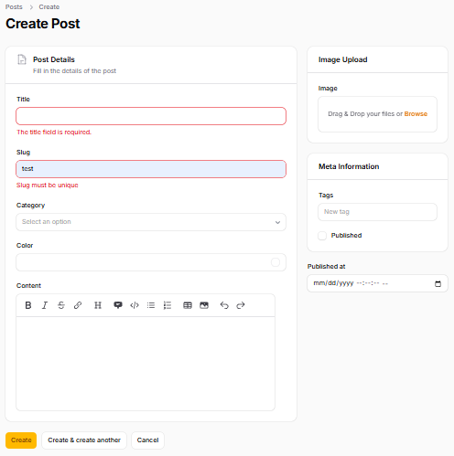
4 | Contoh Validasi Lengkap Post  Modifikasi kode PostForm.php  <?php  namespace App\Filament\Resources\Posts\Schemas;  use DateTime;  use Filament\Schemas\Schema;  use Filament\Forms\Components\TextInput;  use Filament\Forms\Components\Select;  use Filament\Forms\Components\ColorPicker;  use Filament\Forms\Components\MarkdownEditor;  use Filament\Forms\Components\RichEditor;  use Filament\Forms\Components\FileUpload;  use Filament\Forms\Components\TagsInput;  use Filament\Forms\Components\Checkbox;  use Filament\Forms\Components\DateTimePicker;  use Filament\Schemas\Components\Section;  use Filament\Support\Icons\Heroicon;  use Filament\Schemas\Components\Group;  class PostForm  {  public static function configure(Schema $schema): Schema  {  return $schema  ->components([  // Section 1 - Post Details  Section::make("Post Details")  ->description("Fill in the details of the post")  ->icon('heroicon-o-document-text')  ->schema([  Group::make([  TextInput::make("title")  ->rules('required | min:3 | max:10'),  TextInput::make("slug")  ->rule('required')  ->unique()  ->validationMessages([  "unique" => "Slug must be unique"  ]),  Select::make("category_id")  ->relationship("category", "nama")  ->preload()  ->searchable(),  ColorPicker::make("color"),  ])->columnSpan(2),  MarkdownEditor::make("content"),  ])->columnSpan(2),  // Grouping fields into 2 columns  Group::make([  // Section 2 - Image  Section::make("Image Upload")  ->schema([  FileUpload::make("image")  ->required()  ->disk("public")  ->directory("posts"),  ]),  // Section 3 - Meta  Section::make("Meta Information")  ->schema([  TagsInput::make("tags"),  Checkbox::make("published"),  ]),  DateTimePicker::make("published_at"),  ])->columnSpan(1)  ])->columns(3);  }  }  Hasil:  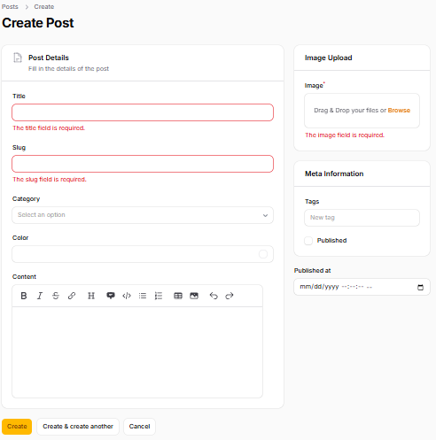
5 | Analisis & Diskusi  1. Mengapa validasi penting pada admin panel?  Jawaban:  - Integritas Data (Data Integrity): Memastikan data yang masuk ke database sesuai dengan format yang diharapkan. Jika kolom tanggal diisi dengan teks biasa, aplikasi publik yang membaca data tersebut bisa crash atau error.  - Keamanan: Mencegah input berbahaya. Tanpa validasi panjang karakter atau tipe file, pihak internal (atau peretas yang membajak akun admin) bisa mengunggah file malware atau memasukkan data super besar yang membuat server tumbang.  - Mencegah Human Error: Staf admin bisa saja lelah atau tidak sengaja salah mengetik (misalnya kurang memasukkan "@" pada email). Pesan validasi membantu memandu mereka untuk memperbaiki kesalahan sebelum disimpan.  2. Apa perbedaan validasi client-side dan server-side?  Jawaban:  Validasi Client-Side (Di Browser):  - Cara kerja: Berjalan di perangkat pengguna (browser) menggunakan HTML5 (seperti atribut required) atau JavaScript.  - Kelebihan: Sangat cepat. Pengguna langsung mendapat peringatan (real-time) sebelum form dikirim ke server. Ini memberikan pengalaman pengguna (UX) yang sangat baik.  - Kelemahan: Sangat tidak aman. Pengguna yang iseng bisa dengan mudah mematikan JavaScript atau menghapus atribut required melalui fitur Inspect Element di browser, lalu mengirim data palsu.  Validasi Server-Side (Di Server):  - Cara kerja: Berjalan di server menggunakan bahasa pemrograman seperti PHP/Laravel setelah tombol submit ditekan.  - Kelebihan: Sangat aman dan mutlak. Ini adalah sumber kebenaran utama. Tidak peduli bagaimana pengguna memanipulasi browser mereka (atau jika mereka mengirim data via aplikasi seperti Postman), aturan di server tidak bisa ditembus.  - Praktik Terbaik: Aplikasi yang baik selalu menggunakan keduanya. Client-side untuk kenyamanan pengguna, dan server-side untuk keamanan absolut.  3. Mengapa unique otomatis bekerja saat edit data?  Jawabam:  4. Kapan kita perlu menggunakan rules array dibanding string?  Jawaban:  - Menggunakan Class/Object Rule Kustom: Jika Anda memanggil class validasi buatan sendiri atau built-in dari Laravel (seperti Rule::unique(), Rule::in(), atau new Password()), Anda tidak bisa menggabungkannya ke dalam string teks. Anda wajib menggunakan array.  Salah: 'required|' . Rule::unique('users')  Benar: ['required', Rule::unique('users')]  - Validasi Regex yang Mengandung Karakter Pipa (|): Jika aturan Anda menggunakan Regular Expression (Regex) dan di dalamnya terdapat simbol | (yang berarti "OR" di Regex), Laravel akan kebingungan jika Anda menggunakan format string, karena ia mengira itu adalah pemisah aturan.  - Aturan Dinamis: Saat Anda perlu menambahkan atau menghapus aturan validasi berdasarkan kondisi tertentu menggunakan kode PHP (misalnya dengan fungsi array_push()), menggunakan format array jauh lebih bersih dan mudah dimanipulasi daripada harus menggabungkan/memecah teks string.
6 | Latihan Praktikum:  1. Tambahkan validasi:  o Title minimal 5 karakter  o Slug unik & minimal 3 karakter  o Category wajib dipilih  o Image wajib diupload  2. Uji semua validasi dengan input salah  3. Buat custom message minimal untuk 2 field  4. Screenshot:  o Error required  o Error min length  o Error unique  Jawaban:  Modifikasi kode program PostForm.php:  <?php  namespace App\Filament\Resources\Posts\Schemas;  use Filament\Schemas\Schema;  use Filament\Forms\Components\TextInput;  use Filament\Forms\Components\Select;  use Filament\Forms\Components\ColorPicker;  use Filament\Forms\Components\MarkdownEditor;  use Filament\Forms\Components\FileUpload;  use Filament\Forms\Components\TagsInput;  use Filament\Forms\Components\Checkbox;  use Filament\Forms\Components\DateTimePicker;  use Filament\Schemas\Components\Section;  use Filament\Schemas\Components\Group;  class PostForm  {  public static function configure(Schema $schema): Schema  {  return $schema  ->components([  // Main Column (Kiri) - Memakan 2/3 layar  Section::make("Post Details")  ->description("Fill in the details of the post")  ->icon('heroicon-o-document-text')  ->schema([  Group::make([  // Validasi 1: Title min 5 karakter + Custom Message  TextInput::make("title")  ->required()  ->minLength(5)  ->validationMessages([  'required' => 'Judul artikel wajib diisi ya!',  'min' => 'Judul terlalu pendek, minimal harus 5 karakter.'  ]),  // Validasi 2: Slug unik & min 3 karakter + Custom Message  TextInput::make("slug")  ->required()  ->minLength(3)  ->unique(ignoreRecord: true) // ignoreRecord agar aman saat proses Edit  ->validationMessages([  'required' => 'Slug tidak boleh kosong.',  'unique' => 'Slug ini sudah dipakai, silakan cari variasi lain.',  'min' => 'Slug minimal 3 karakter.'  ]),  // Validasi 3: Category wajib dipilih  Select::make("category_id")  ->relationship("category", "nama")  ->preload()  ->searchable()  ->required(), // Wajib diisi  ColorPicker::make("color"),  ])->columns(2), // Membagi field di atas menjadi 2 kolom agar rapi  MarkdownEditor::make("content")  ->columnSpanFull(), // Agar editor mengisi penuh ruang horizontal  ])->columnSpan(2), // Memerintahkan Section ini memakan 2 ruang grid  // Sidebar Column (Kanan) - Memakan 1/3 layar  Group::make([  // Section 2 - Image  Section::make("Image Upload")  ->schema([  // Validasi 4: Image wajib diupload  FileUpload::make("image")  ->disk("public")  ->directory("posts")  ->required() // Wajib diisi  ->validationMessages([  'required' => 'Jangan lupa upload gambar sampulnya!'  ]),  ]),  // Section 3 - Meta  Section::make("Meta Information")  ->schema([  TagsInput::make("tags"),  Checkbox::make("published"),  ]),  DateTimePicker::make("published_at"),  ])->columnSpan(1) // Memerintahkan Group ini memakan 1 ruang grid  ])->columns(3); // Membagi total layout form menjadi 3 kolom  }  }  Hasil:  